# <h4>ESP explained</h4>

ESP is a web based tool used to find or change anything in EVE like dungeons, nodes, items, corps, player accounts, player petitions and much more. Each server has its very own ESP address and can be found by simply clicking on the server name located on <a href=“<http://esil.ccpgames.com/>”> <u>http://esil.ccpgames.com/</a></u> </p>

<img src=“esil.jpg”> </p>

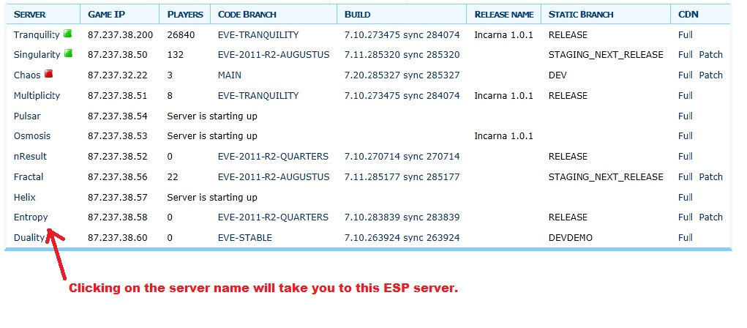

<a id=“esp“/>

## <h4>First Steps</h4>

The first page of ESP will show the tester: </p>

<ul>

* <li>A server population chart </li>
* <li>The “Tunnel to POLARIS” link</li>
* <li>The current server information (Code branch and build version) </li>
* <li>The server list (Used to find out which systems are on a different node) </li>

</ul>

Start off by clicking on the “Tunnel to POLARIS” link. You will then be prompted to enter a username and password. Don’t forget that if you are logged into EVE with an account, that it will be logged out if you use the same account to log into ESP. After logging into ESP you will notice that more options have been added to the menu at the upper right side of the screen. </p>

<img src=“esp_menu.jpg”> </p>

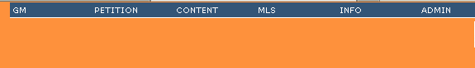

<a id=“esp_locating“/>

## <h4>Locating a User account on ESP</h4>

After the tester has logged in, they will probably want to edit a User/Character in some way. To access the User search form, click on the “Users” link under the “Shared” heading on the ESP homepage. </p>

<img src=“esp_shared.jpg”> </p>



To locate a User, just begin typing their full Username into the search box. It will auto-complete and give the user a drop down menu of possible results. </p>

<img src=”esp_select.jpg” />

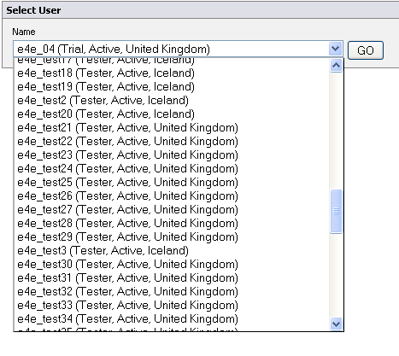

<a id=“esp_user“/>

## <h4>The User’s page</h4>

After selecting a User, the tester will be taken to the User’s page which lists all of the User’s info, their current characters and menus of various pages that edit the User account in different ways (located on the far left and right sides of the screen. </p>

<img src=”esp_user.jpg” />

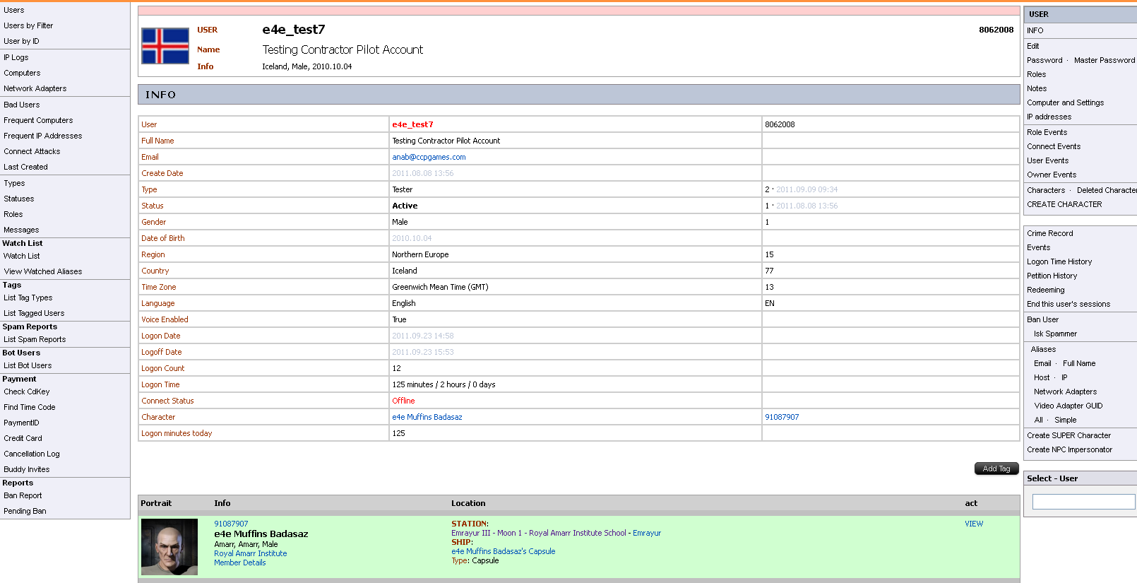

## <h4>The Character page</h4>

After finding a User’s page, the tester can drill down further to look at each of their character’s pages by clicking the “VIEW” link next to the chosen character.</p>

<img src=”esp_character.jpg”/>



Having selected the “VIEW” link, the tester should now be looking at the actual Character page. This looks very similar to the User page that the tester has just left. It contains all the info for the selected character as well as a VERY useful options menu that runs along the right side of the page. </p>

<h4>Deleting a character **</h4>**

The most important thing to remember is that a character <b>cannot be deleted if they are the CEO of a corporation.</b></p>

A character can also be deleted remotely via ESP. This must be done from that particular character’s page. Just below the main info table for the character, you will see a red button that says “Prepare Remove”.</p>



After clicking the button, the tester will be taken to a new page with only a gray button that says the same thing. After clicking that, the tester will be shown a pop up asking “Are you sure?”, if they click the OK button they will be taken back to the Character’s page and will see two new buttons below the Character info. The “Cancel Prepare Move” and Remove” buttons.



After the tester has clicked the “Remove” button they are taken to a new page that only has a gray “Remove Character” button. After clicking the “Remove Character” button, the tester is shown another pop up that asks “Are you sure?” click “OK”.

The character has now been deleted and the character slot in the client is now empty.

## Character page menu

Let me take you on a magical adventure now, and I will attempt to explain some of the more commonly used options of the Character page menu.

## Events (Log)

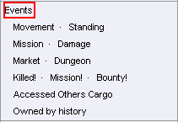

The “Events” link will take the tester to a page that will show them a log of EVERYTHING the character has done or has had done to them. That includes movement, slash command usage, ships destroyed, dungeons entered, etc.

## Moving a character through ESP



* The “Last Station” link: Clicking this will move a character from their current station to the last station that they have docked in.
* The “Last System” link: Clicking this will move a character from their current solar system to the last solar system that they were in.
* The “Move” link: Clicking the “Move” link will open a new page that will allow the tester to move a character to a chosen solar system, space station or world space. These text entry fields will auto-complete after a few letters have been entered and may allow the user to select an option from a drop down list if enough options are available (much like the User search).

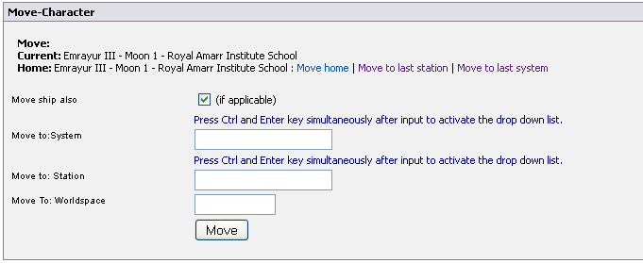

Changing Corporation via ESP **(CAN NOT BE DONE IF THE CHARACTER IS CEO OF A CORP!)**

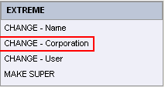

Located in the bottom right corner of the Character page, are the EXTREME options. One of the options allows the tester to change the corporation that a character is currently in, this is “CHANGE - Corporation”. Clicking the link will bring the tester to a new page with a form that looks like this:

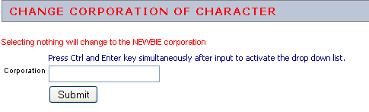

Like most text entry forms in ESP, this will auto-complete after the tester enters a few letters and allow them to select a corporation or faction from the drop down list. As you can see from the screenshot above, if the tester just clicks the “Submit” button, they will be added to a random NPC corporation.